**Class: 15 (16 Nov 2024)**

**Router switch configuration:**

Router port 🡪 interface

┌──(root㉿kali)-[~]

└─# nipper –help

nipper --ios-router --input=ios.conf --output=report.html

┌──(root㉿kali)-[~]

└─$ cd Desktop

┌──(root㉿kali)-[~/Desktop]

└─$ ls

hash router.txt

┌──(root㉿kali)-[~/Desktop]

└─$ nipper --ios-router --input=router.txt --output=JU_report.html

Then open JU_report.html file

SNMP mean ping one ip

What assessment do you find?

Observation and solution (recomandation)

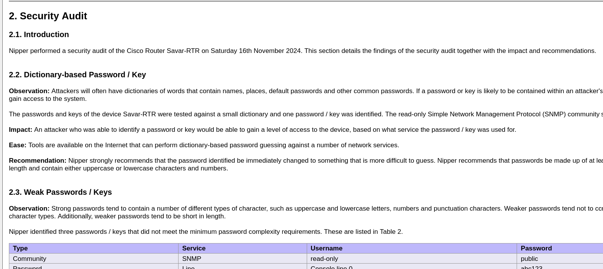

CISCCO –Juniper –Huwaei – Mikrotik 🡪from this router we can easily download configuration file

**Social Engineering Attack**

setoolkit

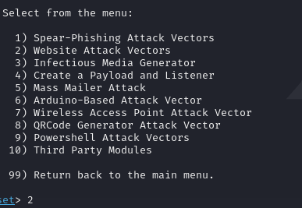

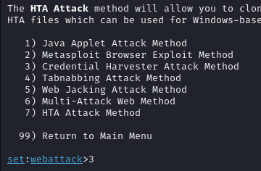

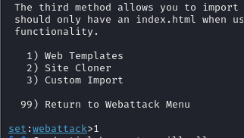

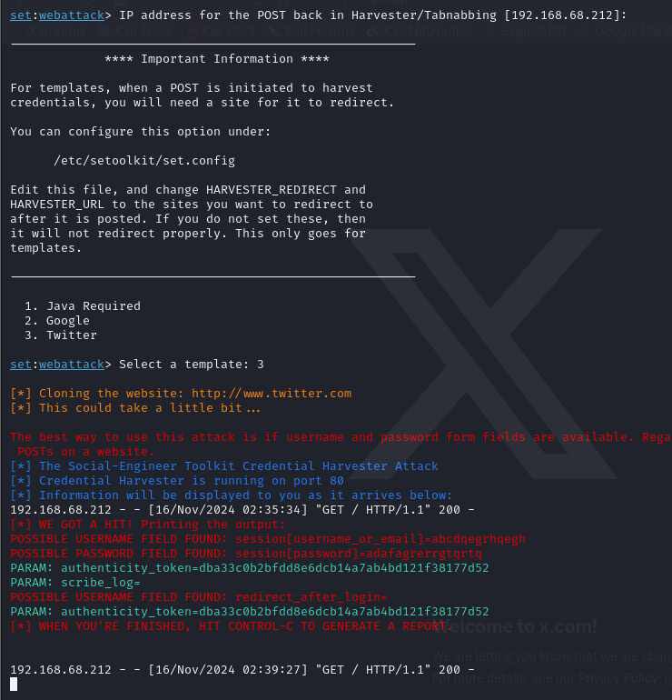

<https://drive.google.com/drive/folders/1B_82khi0rHIkcekExfFkia9h5OrPELYV>